SIMATS ENGINEERING
ASSESSMENT TOOL 2
COURSE NAME: COMPUTER NETWORKS
COURSE CODE: CSA0706

COURSE OUTCOME COVERED
CO4:
Design network topologies star, mesh, bus, and hybrid using networking devices, transmission media, and cabling standards (BL2, BL6)
Assessment Tool Weightage: 30%

Annexure A
Industry Problem Solving Task

Code of Conduct:
IMANIYAM ANUSHKA(192525411) (Name / Reg No) certify that this submission is my original work and that I have adhered to the guidelines specified for this assessment.
I understand that any violation of academic integrity rules will result in disciplinary action.
Signature of the student:MANIYAM ANUSHKA

Annexure A
Industry Problem Solving Task — Answers

1. Star Topology — 20-Person Startup
A star topology is ideal for a 20-person startup because all devices connect to a central switch, making the network easy to manage and troubleshoot. At the core sits a Layer 2/Layer 3 managed switch (such as a Cisco Catalyst or Netgear ProSafe) with at least 24 ports to accommodate all workstations, printers, and VoIP phones with room to grow. Each device connects to the switch using Cat6 UTP cables, which support Gigabit speeds up to 100 meters — more than sufficient for any typical office floor plan. The switch uplinks to a router/firewall (such as a Cisco RV series or pfSense appliance) that handles internet access, DHCP, and network address translation. A Wi-Fi access point connected to the switch extends wireless coverage for laptops and mobile devices. The key advantage of this design is fault isolation: if one workstation's cable fails, only that single node goes offline, leaving all other 19 employees unaffected. Centralised cable management also simplifies future moves, adds, and changes.
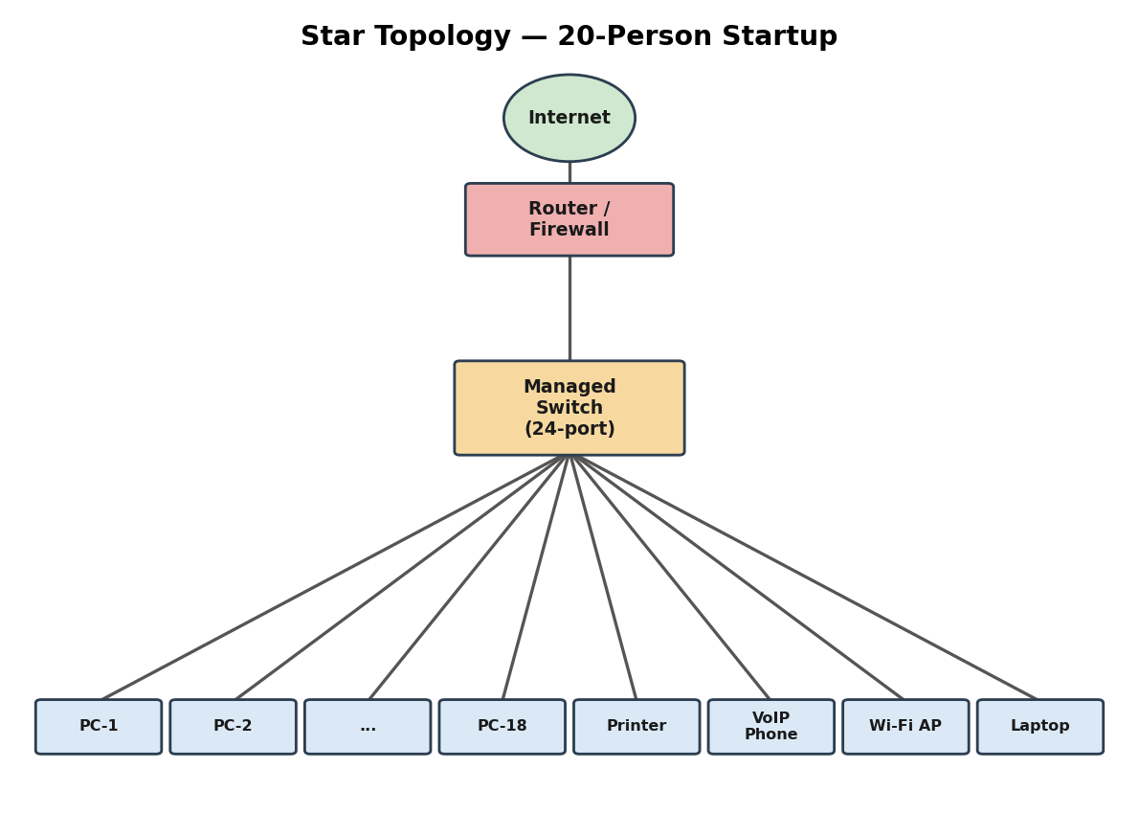
Figure 1: Star topology for a 20-person startup — all endpoints connect to a central managed switch.

2. Mesh Topology — Bank (Near-Zero Downtime)
A bank demands near-zero downtime, making a full or partial mesh topology the right choice. In a full mesh, every core network device — routers, core switches, and servers — connects directly to every other device, so no single link or node failure can bring down the network. For a bank, a partial mesh is typically deployed at the core layer (connecting all core switches and firewalls to each other) while the distribution and access layers use redundant uplinks to at least two core switches. Dual enterprise-grade routers (such as Cisco ASR or Juniper MX series) provide BGP-based redundant internet connectivity. All links between core devices use fiber optic cables — either single-mode for long distances between buildings or multi-mode OM4 within the data center — because fiber is immune to electromagnetic interference, supports very high bandwidth, and is essential for maintaining low-latency financial transactions. Redundant power supplies, UPS systems, and RAID storage arrays further complement the mesh design. The justification is straightforward: when a link fails in a mesh, traffic automatically reroutes through alternative paths in milliseconds using protocols like OSPF or BGP, satisfying regulatory requirements for uptime and data integrity.
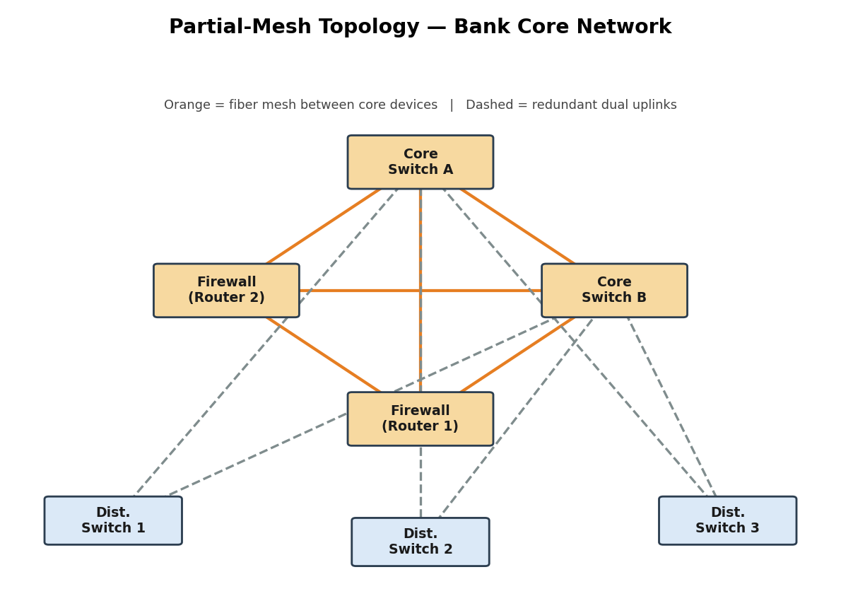
Figure 2: Partial-mesh core for a bank — every core device is interconnected, with redundant dual uplinks from distribution switches.

3. Bus Topology — Classroom Lab (Low Budget)
For a small classroom lab with a tight budget, bus topology offers the lowest hardware cost because all computers share a single common communication line — the bus — eliminating the need for a central switch or hub. A single coaxial cable (RG-58, 50-ohm) or, in a modern variation, a single Cat5e/Cat6 cable daisy-chained through an inexpensive unmanaged hub runs along the length of the room. Each computer connects to the backbone using a T-connector and a BNC connector in a classic coaxial setup, with terminators (50-ohm) placed at both ends of the cable to absorb signals and prevent reflection. For a more contemporary low-cost implementation, a single inexpensive 8- or 16-port unmanaged switch replaces the terminators and uses Cat5e UTP patch cables to each workstation — achieving bus-like simplicity at minimal cost. The primary limitation is that the network is susceptible to collisions and a single cable break disrupts all connected machines, but for a supervised classroom environment with light usage (internet browsing, file sharing), this trade-off is entirely acceptable. No dedicated server is required; a teacher's PC can share resources using built-in Windows/Linux file sharing.
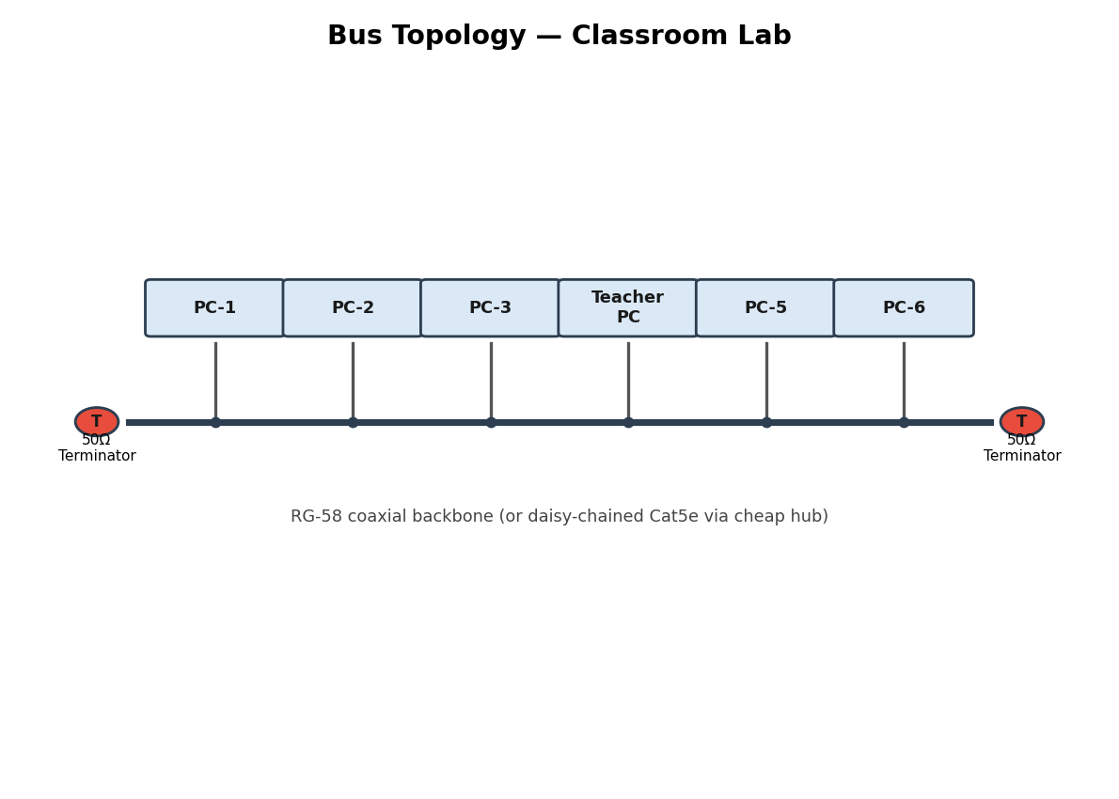
Figure 3: Bus topology for a classroom lab — devices tap off a shared coaxial backbone terminated at both ends.

4. Hybrid Topology — University Campus
A large university campus serves thousands of users across multiple buildings — lecture halls, labs, libraries, dormitories, and administration — making a single topology inadequate. A hybrid topology combines the best elements of multiple designs: a fiber-based ring or mesh at the campus backbone level for redundancy, a star topology within each building for manageability, and bus or tree structures within individual labs for cost-efficiency. At the campus core, high-speed fiber optic cables (single-mode, 10 Gbps or 40 Gbps) interconnect core routers and multilayer switches using a ring or partial mesh arrangement, ensuring that no single link failure isolates an entire building. Each building has its own distribution switch connected to the campus core via dual fiber uplinks. Within each building, a traditional star topology branches from the distribution switch to floor-level access switches, which then connect individual devices via Cat6 cables. This hierarchical three-layer model — core, distribution, and access — is the industry standard for enterprise and campus networks because adding a new building simply means installing a new distribution switch and running fiber to the core, with no disruption to existing infrastructure. Wireless access points throughout the campus connect via PoE (Power over Ethernet) to access switches, eliminating the need for separate power cabling. The hybrid design thus delivers redundancy at the backbone, simplicity at the building level, and scalability campus-wide.
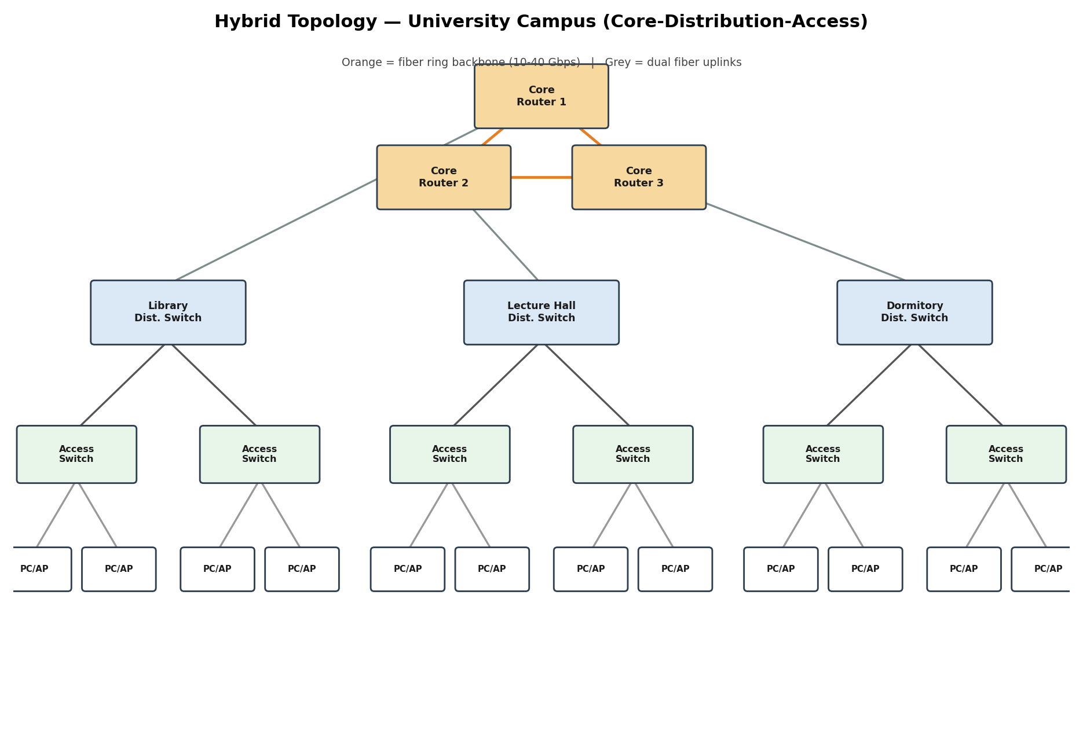
Figure 4: Hybrid three-tier campus design — fiber ring/mesh backbone, per-building star distribution, and access-layer switching.

5. Multi-Department Network with VLANs
Designing a network for a company with multiple departments involves creating a structured and scalable architecture using switches and routers to ensure efficient communication and security. Each department (such as HR, Finance, Sales, and IT) is connected through dedicated Layer 2 switches that form the access layer, allowing devices like computers and printers to communicate within the same department. These switches are then connected to a central Layer 3 switch or router, which acts as the core layer and enables communication between different departments through inter-VLAN routing. Virtual LANs (VLANs) are configured to logically separate each department's network, improving security and reducing broadcast traffic. A router is also used to connect the internal network to external networks such as the internet, often with firewall functionality for security. Redundant links and backup paths can be included to ensure reliability, while proper IP addressing and subnetting are applied for efficient network management. This hierarchical design improves performance, enhances security, and allows easy expansion as the company grows.
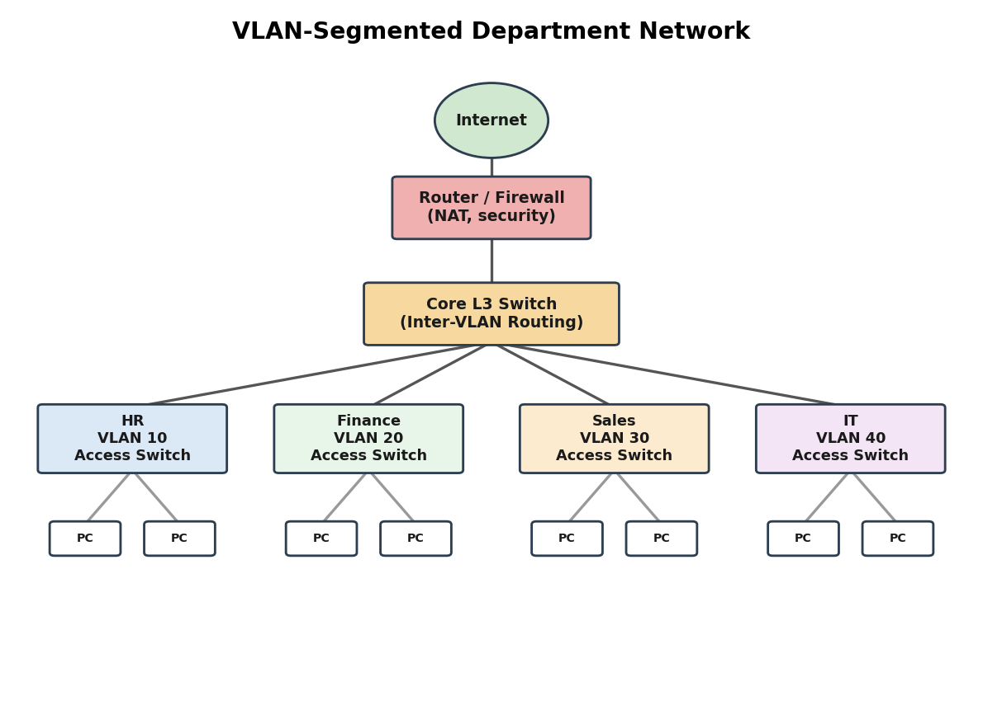
Figure 5: Hierarchical VLAN-segmented design — each department is a separate VLAN, routed via a core Layer 3 switch.

Rubrics for Calculation
Criteria | Weightage | Exemplary (4) | Proficient (3) | Developing (2) | Beginning (1)
Problem Analysis | 15% | Clearly identifies and deeply analyzes the industry problem with all factors | Good understanding with minor gaps | Basic understanding; some key aspects missing | Poor or incorrect understanding of the problem
Solution Design | 20% | Innovative, practical, and industry-relevant solution | Effective solution with minor limitations | Partially suitable solution | Inappropriate or unclear solution
Technical Implementation | 20% | Fully functional, accurate, and well-executed implementation | Mostly functional with minor errors | Partially implemented solution | Incomplete or non-functional implementation
Use of Tools & Technologies | 10% | Appropriate and advanced use of relevant tools and technologies | Correct use of tools | Limited or basic use of tools | Incorrect or no use of tools
Problem-Solving Approach | 10% | Logical, systematic, and well-structured approach | Mostly logical approach | Somewhat disorganized approach | No clear approach
Innovation & Creativity | 10% | Highly creative and original solution | Some creativity | Limited originality | No creativity
Testing & Validation | 5% | Thorough testing with real-world scenarios | Adequate testing | Minimal testing | No testing
Documentation & Presentation | 5% | Clear, professional, and well-documented | Good documentation | Basic documentation | Poor or no documentation
Teamwork / Collaboration | 5% | Excellent coordination and contribution (if team-based) | Good collaboration | Limited participation | No collaboration or contribution

